 | 

PRELIMINARY DESIGN FOR UI.City UI.State, UI.Country
UI.Name.First UI.Name.Last
UI.Organization

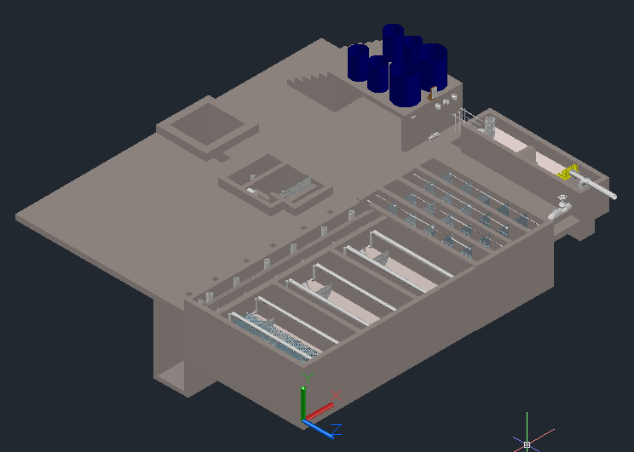
Copyright © 2010 Cornell University
Table of Contents
Disclaimer 4
Permission and Licensing Information 4
Introduction to AguaClara 5
The sustainable approach 5
The treatment process 6
The AguaClara Design Tool 7
The Technology 8
Determination of the hydraulic design 8
Plant Components 9
Coagulant Tanks 9
Entrance Tank/Pre-sedimentation 10
Chemical Dose Controller 14
Calibrating the doser 16
Rapid Mix 17
Flocculation 17
General Flocculator Design 18
Inlet Channel 18
Sedimentation Tanks 19
Assigning dimensions to the sedimentation tank 20
Inlet Manifolds 21
Sludge drain 23
Tolvas 23
Plate settlers 23
Launders 24
Canal de salida 25
Chlorine Disinfection 25
Manejo de lodos 26
Stacked Rapid Sand Filtration: SRSF 26
Materials List 29
Entrance Tank 29
Flocculation Tank 29
Sedimentation Tank 30
SRSF 30


http://aguaclara.cee.cornell.edu/
Dr. Monroe Weber-Shirk, Director

This preliminary design was requested by UI.Name.First UI.Name.Last on behalf of UI.Organization. The design was created on November 8, 2026 at 1:19:19 AM by the AguaClara Design Server at Cornell University. The design is for UI.City UI.State, UI.Country and has a design flow rate of Q.Plant. The design was created with MathCAD code version SVN.Version.
This design is the result of over 20,000 hours of undergraduate, graduate, and faculty labor. The design incorporates advanced fluid dynamics analysis for the hydraulic design to minimize floc breakup between the flocculator and the sedimentation tank. The chemical feed system is based on a series of inventions by the AguaClara team that make it possible to directly set the desired chemical dose and to maintain that dose automatically even as the flow rate through the plant varies. The high rate, shallow sedimentation tank design is optimized for high performance, low cost of construction, and ease of maintenance. The fabrication techniques that make it possible for a single operator to completely disassemble a sedimentation tank while keeping the rest of the plant in operation were developed by the AguaClara team at Cornell and by our partners in Honduras.
The economic value of this design is approximately 10,000 USD. This estimate is based on the amount of time that would be required to create this design if an environmental engineering firm used the AguaClara design algorithms, but not the automated design tool, to create this design. The AguaClara team is committed to continue providing this design service because we want to encourage new implementation partners to explore the use of this technology. We also recognize that high design costs would prevent this technology from being available to small communities. However, we do require funding to maintain our design team and to continue to integrate improvements into our designs. We recommend that implementation partners include a design fee for the AguaClara design service in the project budget. The recommended nominal fee (far below its true value) for use of this design service is 100 USD per L/s of plant capacity. You are welcome to create multiple designs for each facility that you intend to construct to obtain an optimal plant configuration. This recommended fee can be paid to AguaClara by check or online to Cornell University. This fee will likely be between 1% and 2% of the overall project cost for a water treatment plant. Thank you for your support.

Donate by Check
Make the check to Cornell University
Write AguaClara in the memo field
Mail to: AguaClara, 220 Hollister Hall, Cornell University, Ithaca, NY 14853

Disclaimer
This document is a DRAFT. It has not been reviewed for official release. It is included with the design files to show what we plan to deliver in the near future.
This design, including the files accompanying this document, is only a draft and must be reviewed and approved by a licensed engineer prior to construction. If you have questions about this design please contact the AguaClara design team at Cornell University at CUAguaClara@gmail.com.

Permission and Licensing Information
Copyright © 2010 Cornell University
Authors: The AguaClara team at Cornell University under the supervision of Dr. Monroe Weber-Shirk
This design was created using the open source engineering services of the AguaClara program at Cornell University. It is subject to the Creative Commons Attribution-ShareAlike 3.0 United States license. If you alter, transform, or build upon this work, you may distribute the resulting work only under the same, similar or a compatible license.
Permission to use this AguaClara Design Tool along with the subsequent AutoCAD renderings and supporting files for design specifications provided by Cornell based on your input parameters (collectively "WORK") and their associated copyrights without a written agreement is hereby granted. Any water treatment plants built using this WORK shall be designed and supervised by a licensed civil engineer.
IN NO EVENT SHALL CCTEC, CORNELL UNIVERSITY, OR THEIR EMPLOYEES BE LIABLE TO ANY PARTY FOR DIRECT, INDIRECT, SPECIAL, INCIDENTAL, OR CONSEQUENTIAL DAMAGES, INCLUDING LOST PROFITS, ARISING OUT OF THE USE OF WORK AND ITS ASSOCIATED COPYRIGHTS, EVEN IF CCTEC OR CORNELL MAY HAVE BEEN ADVISED OF THE POSSIBILITY OF SUCH DAMAGE.
THE WORK PROVIDED HEREIN IS ON AN "AS IS" BASIS, AND CCTEC, CORNELL, AND THEIR EMPLOYEES HAVE NO OBLIGATION TO PROVIDE MAINTENANCE, SUPPORT, UPDATES, ENHANCEMENTS, OR MODIFICATIONS. CCTEC, CORNELL, AND THEIR EMPLOYEES MAKE NO REPRESENTATIONS AND EXTEND NO WARRANTIES OF ANY KIND, EITHER IMPLIED OR EXPRESSED, INCLUDING, BUT NOT LIMITED TO, THE IMPLIED WARRANTIES OF MERCHANTABILITY OR FITNESS FOR A PARTICULAR PURPOSE, OR THAT THE USE OF WORK AND ITS ASSOCIATED COPYRIGHTS WILL NOT INFRINGE ANY PATENT, TRADEMARK OR OTHER RIGHTS.
Users of WORK shall indemnify, hold harmless and defend Cornell, its officers, employees, agents, and the sponsors of the research that let to WORK against any and all claims, suits, losses, damage, costs, fees, and expenses resulting from or arising out of use of WORK. This indemnification shall include, but not be limited to, any product liability. Users of WORK, at their sole cost and expense, shall sufficiently insure their activities in connection with the WORK and obtain, keep in force, and maintain insurance or an equivalent program of self insurance. Cornell shall notify users of WORK in writing of any claim or suit brought against Cornell in respect of which Cornell intends to invoke the provisions of this paragraph. Users of WORK shall keep Cornell informed on a current basis of its defense of any claims under this paragraph.

Introduction to AguaClara

The sustainable approach

AguaClara is a program in Civil and Environmental Engineering at Cornell University that is improving drinking water quality through innovative research, knowledge transfer, open-source engineering, and replicable design of sustainable municipal water treatment systems.
The team is directed by Monroe Weber-Shirk and has worked in partnership with Agua Para el Pueblo, a Honduran NGO specializing in water supply systems, to implement the technologies in rural towns. The AguaClara program received the 2011 Intel Environment Tech Award in recognition of the success of the program in developing sustainable technologies and effective governance models.
Cornell-designed AguaClara municipal water treatment plants are providing six Honduran towns with populations between 1,500 and 15,000 with safe drinking water from their taps. The AguaClara plants produce safe drinking water with turnkey design, construction, operation, training, and transfer costs of $20 to $30 per person served and incremental operating costs of $2-$4 per person per year.
The AguaClara technology is uniquely capable of producing high quality drinking water from turbid surface waters without using electricity. The facilities use gravity powered chemical dosing, hydraulic flocculation (to form large aggregates from the contaminants, or flocs), high-rate sedimentation using custom-fabricated plate settlers (to remove the flocs), stacked rapid sand filtration, and disinfection using liquid chlorine (to kill any residual pathogens that escaped the previous treatment steps). The designs rely on materials that are sourced in the community and national supply chains. The municipal water treatment plants are designed to be easy and economical to operate.
Extending safe drinking water coverage to resource poor communities requires multiple engineering innovations and a new approach to implementation and governance. Our robust technologies do not require electricity or external power sources. Our governance model is based on community ownership, community-based democratic governance, and technologies that are specifically designed to be easy to operate and to encourage pride in ownership. We build implementation partner capacity and intend to encourage the formation of a network of implementation partners that will share best practices for implementation and long-term operation of community-based water treatment facilities.
This integrated model of technology development for compatibility with a sustainable governance model has proven extremely successful. All AguaClara facilities are owned and operated by their respective communities and all facilities continue to provide safe drinking water. This is particularly noteworthy in Honduras where most water treatment plants for large cities do not reliably meet drinking water standards. Several towns with AguaClara facilities are experiencing reverse migration from Tegucigalpa due to their superior water.
Democratic community governance through an elected water board has proven to be very effective and the water boards use the water tariffs (that the community has voted to increase) to fund improvements to their water supply infrastructure. Water boards with AguaClara facilities have invested in reforestation of their watershed, upgrades to their distribution system, extensions to their distribution system to add new customers, and ongoing maintenance of the water supply infrastructure. Customer willingness to pay for safe drinking water is significantly higher than their willingness to pay for unsafe river water and the difference is greater than the increased operation and maintenance cost of providing safe drinking water using AguaClara technologies.
Our goal is to disseminate this technology and our learning regarding sustainable governance globally. The AguaClara engineering designs are shared online to facilitate technology dissemination and to reduce design costs. National engineering firms (non-profit, private, or governmental) are trained to build the water treatment facilities using locally available materials and community labor. Our partners work with locally-trusted organizations to develop a governance model that is suited to the natural resources, national governance framework and available social and human capital of a particular community.
We are seeking funding that will support our research and development work to extend the range of community sizes that can be served using the AguaClara technologies. We have experience with communities between 1,500 and 15,000 and plan to extend that range in both directions. We are researching several technologies that have the potential to reduce the construction and operating costs of the water treatment plants and need funding to support that effort. There are significant engineering and governance challenges as we develop approaches to community based water treatment for communities with fewer than 1,500 inhabitants. Extending our design capabilities for treatment facilities that can serve larger cities is easier. The engineering and technical challenges will require developing new fabrication methods, testing prototypes for performance, and coding the new designs for dissemination via our online design tool.
We are also interested in testing models for implementation and governance. Our experience suggests that partnerships between the AguaClara team at Cornell, implementation partners, and community governance bodies realize their full potential when there is a high level of trust between the organizations and an ongoing technical assistance circuit rider. The AguaClara technologies are designed to encourage the creation of trust and self sufficiency by being easy to understand and easy to maintain even in resource poor communities. We would benefit from experiences with different types of implementation partners and with more governance and technical assistance models to learn which approaches are most effective for various situations.
The AguaClara program overcomes the major barriers to safe drinking water that were previously encountered by small communities. We estimate that well over 100 million people living in Latin America and the Caribbean, Africa, and Asia could benefit from these technologies. The resilient design, innovative fabrication methods based on locally available materials, the automated design tool, and community based governance hold the prospect of improving the quality of life in thousands of communities in the coming years.

The treatment process

AguaClara plants treat turbidity, pathogens, and natural organic matter using rapid mix, coagulation/flocculation, sedimentation, and rapid sand filtration proceses. The treatment process begins with removal of large debris and preliminary sedimentation of large particles. Then coagulant, which promotes the aggregation of suspended particles, is added to the raw water through a semi-automatic chemical dosing system. The coagulant is mixed with water in a rapid-mix pipe, which delivers macro-scale mixing through minor losses due to pipe configuration, and micro-scale mixing through an orifice plate. The rapid-mix pipe carries the mix of water and chemical coagulant to the flocculation tank, where it is forced through a series of 180 degree turns created by the staggered baffles within. The 180 degree turns ensure sufficient collisions among the suspended particulates to form larger aggregate particles, or flocs.
The flocculated water is then delivered to the bottom of the sedimentation tank through a series of diffusers, which ensure that the flow is directed vertically into the tank. The bottom geometry of the sedimentation tank has been designed to suspend flocs in the middle portion of the tank, creating a floc blanket which itself acts as a filter for other flocs. The top of the tank has a several closely-spaced plates, known as lamella, to shorten the horizontal distance a particle must travel before encountering an obstruction and settling down to the bottom of the tank. The water flowing up from the lamella has been cleaned of most flocs and can then be carried to the stacked rapid sand filter.
AguaClara’s one-of-a-kind stacked rapid sand filter is composed of six sand layers arranged one on top of the other. The water from the sedimentation tank is divided evenly and delivered to every other sand layer by a pipe network. The main pipelines are connected to a series of slotted pipes, which spread the settled water throughout the plan view area of each layer. As water travels through the sand layers, the remaining flocs are captured in the pore space of the sand, and the filtered water is collected by the receiving sand layers (the remaining three layers that did not deliver water into the filter). A siphon system and pipe stubs that vary the water outlet elevations enable the filter to self-backwash, minimizing demand on the operator.
The final step in the Aguaclara water treatment process is disinfection. The semi-automatic chemical doser delivers chlorine to the filtered water. The chlorinated water is stored in a distribution tank to allow for sufficient contact time with the chemical, ensuring the water is fully disinfected. After disinfection, the treated water is ready for distribution to households. Water treated by the AguaClara system is consistently below 5 nephelometric turbidity units (NTU), and frequently meets the US standard for maximum turbidity, 0.3 NTU.

The AguaClara Design Tool

In the Aguaclara Design Tool (ADT), the basic design parameters requested (e.g. flow rate, wall thickness, number of sedimentation tanks desired, the dimensions of purchased lamella material, etc.) are used as variables in a series of hydraulic and geometric algorithms that define the dimensions of the plant reactors and their accessories. The design algorithms in the ADT are based on fundamental physics, and thus are scalable over a wide flow range. Algorithms have been revised and constrained based on lab research and feedback from the field to ensure both efficient material usage and ease of operation. The software output based on these parametric algorithms is a three-dimensional drawing in AutoCAD of each reactor that is to be given to the designer. The designer completes the design based on the ADT output by adding the final treatment components, the plant building, and distribution system, and then the designer must perform a full structural analysis of the plant. This document provides a summary of Aguaclara processes with regard to the design of closed facilities. Consequently, all calculated values (e.g. lengths of plant reactors, distances between the centers of the orifices, etc.) are specific to this plant design, and do not necessarily apply to other Aguaclara plants.

Design Parameters

Included is the design for a plant for UI.City having a maximum flow rate of Q.Plant L/s based on user inputs to the ADT, shown in Table i below. The software uses these parameters as variables in a series of hydraulic and geometric calculations that define the dimensions of the various plant components. The goal of the plant with respect to water quality is to reduce the as much as possible and to have it meet international water quality standards (less than 5 NTU), maintain the color within norms (15 Unidades de Color – UC), disinfect the water with chlorine, and maintain a residual chlorine concentration throughout distribution between 0.3 and 1.0 mg/L. The plant treats water without using electricity, utilizing pre-sedimentation, flow control, rapid mix, coagulation/flocculation, hydraulic upflow sedimentation, filtration, and chlorination.

Maximum flow rate | Q.Plant
Thickness of the plant walls | T.PlantWall
Minimum concrete thickness | T.ConcreteMin
Coagulant stock concentration | C.CoagStock
Turnover time for the coagulant stock | Ti.CoagStock
Number of sedimentation tanks | N.SedTanks
Number of sedimentation bays | N.SedBaysEst
Width of the lamella used for sedimentation plates | W.SedPlate
Length of the lamella used for sedimentation plates | L.SedPlateSheet
Thickness of the lamella used for sedimentation plates | T.SedPlate
Thickness of the weirs in the sedimentation tanks | T.SedWeir
Table 1. User inputs to the Automated Design Tool used to calculate the included design.
Based on the given parameters, the specific dimensions, parameters, and material characteristics of each plant component have been calculated by the ADT. This information is summarized in Table ii. The treatment processes have been designed according to the maximum flow rate, Q.Plant L/s. The hydraulic processes of the plant include pre-sedimentation, coagulation, flow control, rapid mix, EN.FlocType hydraulic flocculation, hydraulic upflow sedimentation, filtration, and chlorination.

Maximum plant flow rate: | Q.Plant
Treatment process: | Semi-automatic coagulant (Alum or PAC) doser, rapid mix, EN.FlocType hydraulic flocculation, upflow sedimentation with lamella, filtration, chlorination
Approximate head loss: | HL.PlantTotal
Number of chemical dosers: | 2
Number of coagulant tanks: | 4
Type of coagulant doser | Laminar flow gravity doser
Coagulant stock concentration: | C.CoagStock
Type of rapid mix: | Turbulent flow in a ND.RMPipe pipe
Number of flocculation tanks: | 1
Number of channels in a flocculation tank: | N.FlocChannels
Dimensions of each flocculation tank: | W.FlocChannel in width  L.FlocTank in length  H.Floc in depth
Hydraulic residence time in the flocculator for the maximum design flow rate | Ti.Floc
Number of baffles in the flocculation tank: | N.FlocBaffles
Material of the baffles in the flocculation tank: | Láminas plásticasLáminas plásticas
Dimensions of the inlet channel to the sedimentation tank: | L.SedChannel in length  W.SedInletChannel in width  H.SedInletChannel in depth
Number of sedimentation tanks: | N.SedTanks
Number of sedimentation bays per sedimentation tank: | N.SedBays
Dimensions of the sedimentation tank: | W.Sed in width  L.Sed in length  H.Sed in depth
Hydraulic residence time in the sedimentation tanks for the maximum design flow rate: | Ti.Sed
Total number of sedimentation plates: | N.SedPlatesTotal
Angle of the sedimentation plates: | AN.SedPlate
Length of the sedimentation plates: | L.SedPlate
Perpendicular space between sedimentation plates: | S.SedPlate
Upflow velocity in the sedimentation tanks at the maximum design flow rate: | V.SedUpBod
Capture velocity of the sedimentation tanks at the maximum design flow rate: | V.SedCBod
Number of chlorine storage tanks: | 2
Type of chlorine doser: | Laminar flow gravity doser
Table 2. Plant characteristics for a Q.Plant L/s plant designed for UI.City, UI.Country.

Plant Components

Entrance tank/preliminary sedimentation

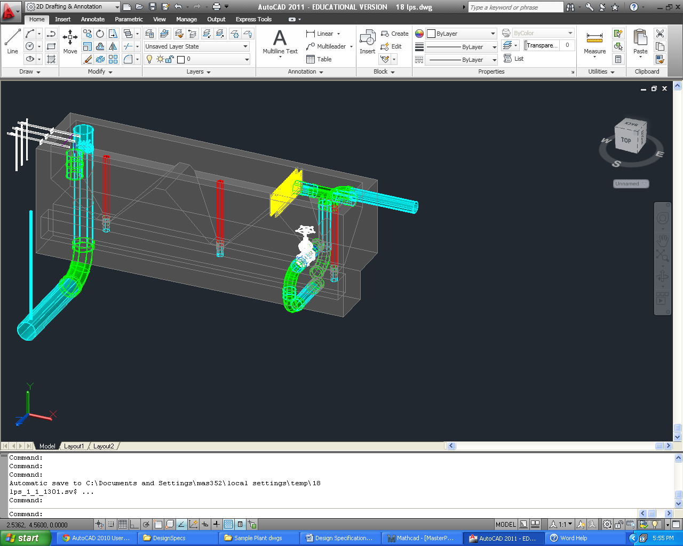
The main functions of the entrance tank are to remove solids from the water through preliminary sedimentation, to measure the flow through the plant, and to provide a place where the quality of the raw water can be observed. The preliminary sedimentation process removes solids such as sand, silt, and clay from the water before applying the coagulant to the influent. Water enters the plant on the right side of the entrance tank shown in Figure 1 and flows linearly over the top of the inverted pyramidal traps, or hoppers, at the bottom of the tank. The first hopper contains an overflow weir pipe to waste any water entering the plant in excess of the plant flow rate. The overflow pipe has a nominal diameter of ND.EtOverflowDrain, sized to handle half of the total plant flow rate. A slot is cut from the pipe such that 10% of the vertical dimension of the pipe is lost, giving a W.EtOverflowSlot m wide opening, starting at a height of H.EtOverflowCutaway m below the natural inner diameter of the pipe. The length of the slot is designed to fit along the length of the first hopper, giving an effective weir length (two times the slot length) of L.EtOverflowWeir m. A drain is also embedded into the first hopper, allowing the operator to manually adjust the plant flow rate by opening the flow control valve by a desired amount, wasting water into the channel below. The ND.EtFlowControl in nominal diameter drain is designed to handle the drain the full plant flow rate if needed.
inlet pipe
linear flow orifice meter
overflow weir pipe
trash racks
flow control valve
chemical dose controllers
rapid mix pipe
air removal pipe
hopper stops
Figure 1. A sample entrance tank for an 18 L/s plant. Water enters the tank through the inlet pipe shown at the right. Water flows linearly over the hoppers to the end of the tank, where it flows into the orifices of the linear flow orifice meter, and then on to the flocculator.
Large particulates settle out into the hoppers, and collect near the drains at the bottom. When the water reaches the end of the tank, it flows through the orifices of the riser pipe, which acts as a linear flow orifice meter (LFOM). It is designed for a capture velocity of W.EtCapture to remove these particulates. A length of L.Et is assigned to the entrance tank to correspond to the sedimentation tank length plus enough space to fit the float of the chemical dose controller and the rapid mix pipes. The width, W.Et, is then assigned to ensure the minimum desired capture velocity is met while still allowing enough space for a person to fit inside and construct the tank. The depth of the tank is then determined such that the velocity in the upper rectangular portion of the tank does not exceed the velocity in the flocculator, V.Floc, while ensuring the depth is sufficiently small that the drains are easy to access. In this case, the tank has a height of H.Et.

To allow for easy maintenance, N.EtHoppers hoppers must be built into the entrance tank, at an angle of AN.EtSlope, forcing sediments to slide to the bottom where the ND.EtDrain drains are located. When too much sediment has accumulated, the upper drain pipes must be removed until the sludge is flushed out. Directly below the entrance tank, there is a drain channel to collect the waste.

As the raw water flows from the first hopper to the subsequent ones, it must pass through two trash racks, preventing large debris from entering the treatment process. Having two trash racks allows the plant to run with a grit screen even while the operator cleans one of them. The trash racks are made of rebar and slide into two slots built into the entrance tank wall. The center-to-center distance between the rebar, B.EtRebar m, is set to ensure that debris large enough to clog the orifices in the linear flow orifice meter downstream (LFOM) are kept out.
Suspended particulates in the water settle out over the length of the entrance tank into the hoppers below. When enough sludge has accumulated at the bottom, the hopper stops can be removed to flush out the debris down into the drain channel below, and they can then be replaced to resume normal operation. The ND.EtDrain in nominal diameter hopper stop is L.EtDrainStopper m long, ensuring the top of the pipe is above the maximum water height in the tank. Table 3 summarizes the entrance tank design specifications below.

Entrance Tank
Residence time
Capture velocity
Tank length | L.Et m
Tank width | W.Et m
Tank height | H.Et m
Hopper length | L.EtHopper m
Hopper height | H.EtHopper m
Last slope height | H.EtLastSlope m
Hopper side slope angle | AN.EtSlope deg
Hopper back slope angle
Thickness of ledge between hoppers | T.EtHopperLedge m
Number of full hoppers | N.EtFullHopper
Hopper Drains
Hopper drain diameter | ND.EtDrain in
Hopper stop length | L.EtDrainStopper m
Flow Control Components
Flow control valve diameter | ND.EtFlowControl
Overflow weir pipe diameter | ND.EtOverflowDrain
Overflow weir pipe slot length
Overflow weir slot depth
Trash Rack
Trash rack rebar spacing
Trash rack rebar diameter
Table 3. Entrance tank characteristics for UI.City.

Linear flow orifice meter (LFOM)

The linear flow orifice meter, or LFOM, is the riser pipe found in the leftmost hopper of the entrance tank. Water exits the entrance tank through the orifices in the LFOM, is dosed with coagulant, undergoes rapid mix, and then enters the flocculation tank. The diameter of the pipe is set such that cross-sectional area of the pipe required is Pi.LfomSafety times the minimum area required to carry the average velocity of water in the pipe, giving a ND.RMPipe in nominal diameter pipe. The additional area ensures that water free falls into the rapid mix pipe so the flow in the pipe is hydraulically disconnected from the flow through the entrance tank. The orifice pattern in the LFOM is designed to approximate the shape of a sutro weir, which forces a linear relationship between the flow rate over the weir and the head loss over the weir. The maximum head loss over the weir is set to be HL.Flowmeasure m, since the sutro weir approximation is not valid at higher head losses. Assuming a B.LfomRows m spacing between the rows of orifices, the theoretical flow area required in the top B.LfomRows m of the LFOM can be calculated, and the orifice size is set to be no larger than that to ensure at least one orifice can be placed in the top row. This design requires D.LfomOrifices m diameter orifices. The number of orifices in each row is calculated by minimizing the mean square error as compared to perfectly linearized flow. Table 4 gives the orifice pattern for this specific design.

Row Height (m) | Number of Orifices
H.LfomOrifice1 | N.LfomOrifices1
H.LfomOrifice2 | N.LfomOrifices2
H.LfomOrifice3 | N.LfomOrifices3
H.LfomOrifice4 | N.LfomOrifices4
H.LfomOrifice5 | N.LfomOrifices5
H.LfomOrifice6 | N.LfomOrifices6
H.LfomOrifice7 | N.LfomOrifices7
H.LfomOrifice8 | N.LfomOrifices8
H.LfomOrifice9 | N.LfomOrifices9
H.LfomOrifice10  Table 4. The orifice pattern in the LFOM for UI.City. The row height is measured from the bottom of the orifices in the first row. | N.LfomOrifices10

Chemical dose controller (CDC)

The chemical dose controller is hydraulically connected to the entrance tank, enabling the control system to automatically adjust the flow of chemical solution through the plant to maintain the desired dose at even varying flow rates. As pictured in Figure 2, a ND.EtFloat diameter pipe float hangs from the dosing lever arm and sits in the last hopper of the entrance tank. The left side of the lever arm is marked with a dosing scale and has a drop tube attached to a slider. The operator moves the slider along the left side of the arm to set the desired dose. This float “reads” To administer the dose of chemicals without pumps, AguaClara plants utilize a dosing system that consists of tanks to store the coagulant solution, a platform to maintain the needed elevation of the solution, a constant head tank with a float valve, a dosing scale, and a dosing tube. The chemical dose controller automatically adjusts the flow of chemical through the plant to maintain a desired dose, even as the plant flow rate changes.
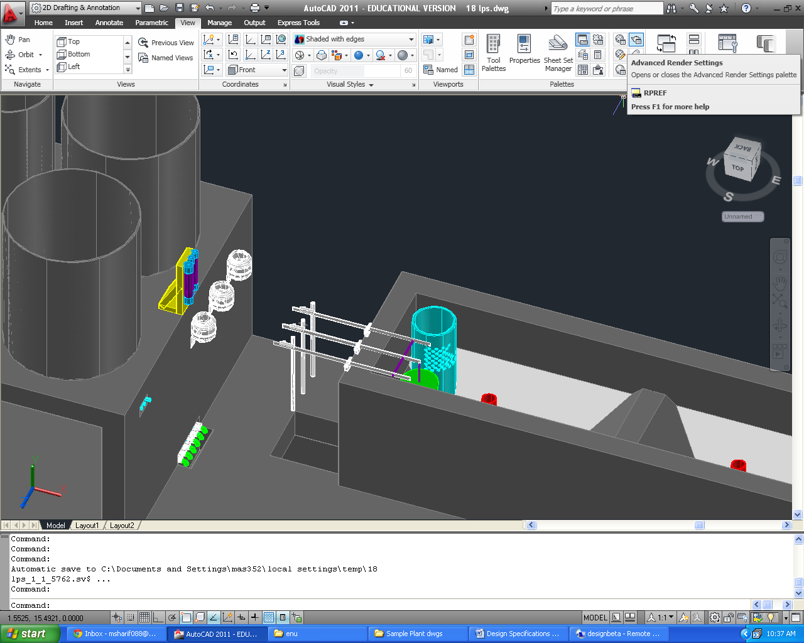
Figure 2. The chemical dosing center for an 18 L/s plant. The dosing lever arm is mounted to the left side of the entrance tank, and the constant head tanks are mounted on the east wall of the chemical stock tank platform.
constant head tanks
chemical calibration columns
chemical stock tank drains
chemical stock tanks
dosing arms with scales
drop tubes
float

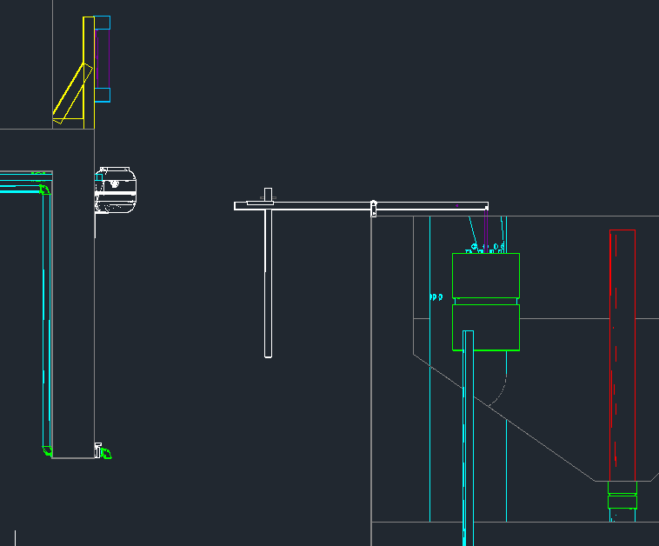
constant head tank
dosing tube
weight
float
drop tube
LFOM pipe

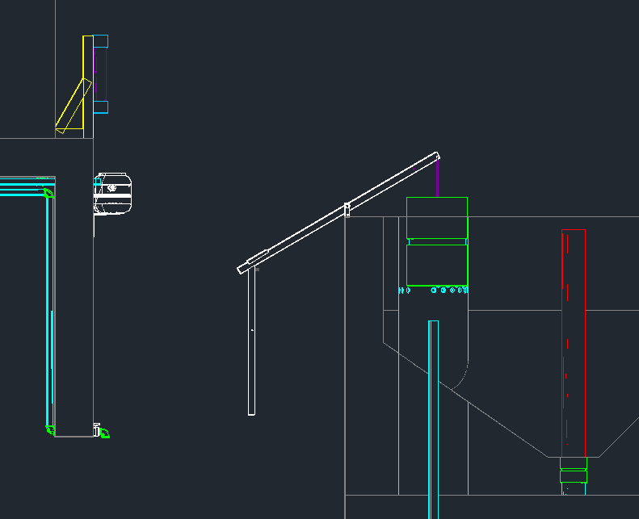

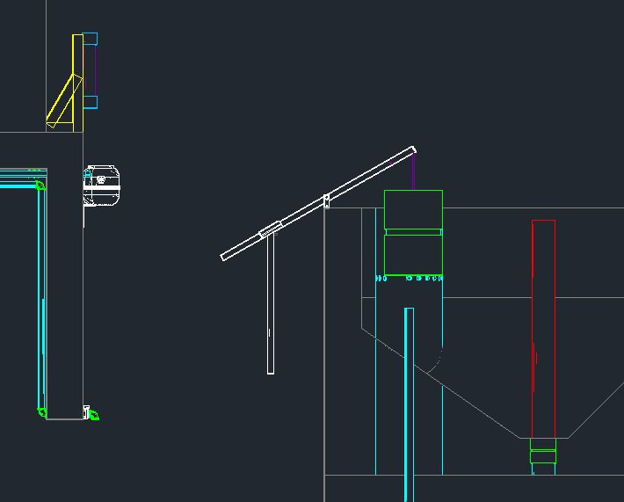

Chemical Dose Controller Specifications
Float diameter
Float height
Lever arm length
 | Chemical stock concentration |  | Maximum head loss |  | Float valve orifice diameter | Stock tank to constant head tank tube diameter |  | Large tube diameter
Main plant coagulant
Chlorine
Filter coagulant
Chemical Dose Controller Tube Design
 |  | Number of Tubes |  | Length of Tube |  |  | Diameter of Tube
Main Plant Coagulant
Chlorine
Filter Coagulant
Table 5. Chemical dose controller design for UI.City.

Chemical storage tanks

There are two storage tanks for each chemical on the stock tank platform. The design of the chemical storage tanks is based on the tank volumes available for purchase through Rotoplast for Latin America, and it is assumed that the stock tank will be refilled no more frequently than every Ti.StockMin hours. In order to determine the required volume of a chemical tank, the maximum chemical flow rate, Q_{ChemStockMax}, must first be determined as follows:
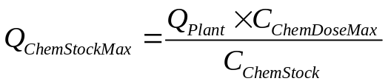

where Q_{Plant} is the maximum plant flow rate, C_{ChemDoseMax} is the maximum allowable chemical dose, and C_{ChemStock} the the stock concentration in the chemical tank. Using the maximum chemical flow rate, the volume of the stock tank, V_{ChemTank}, is computed using the following formula:
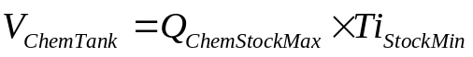
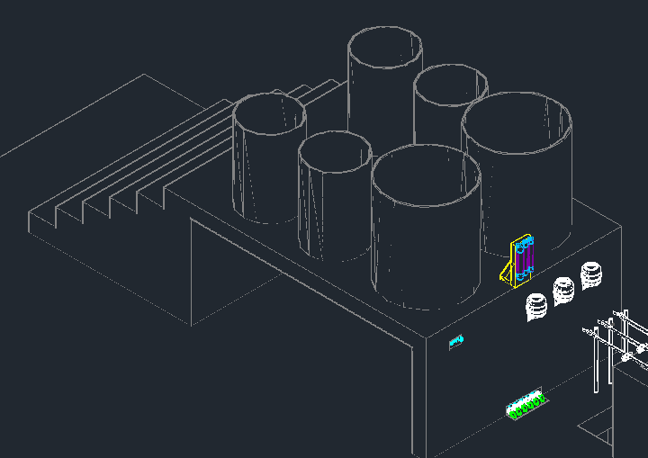
Figure 1. Chemical stock tanks for an 18 L/s plant.

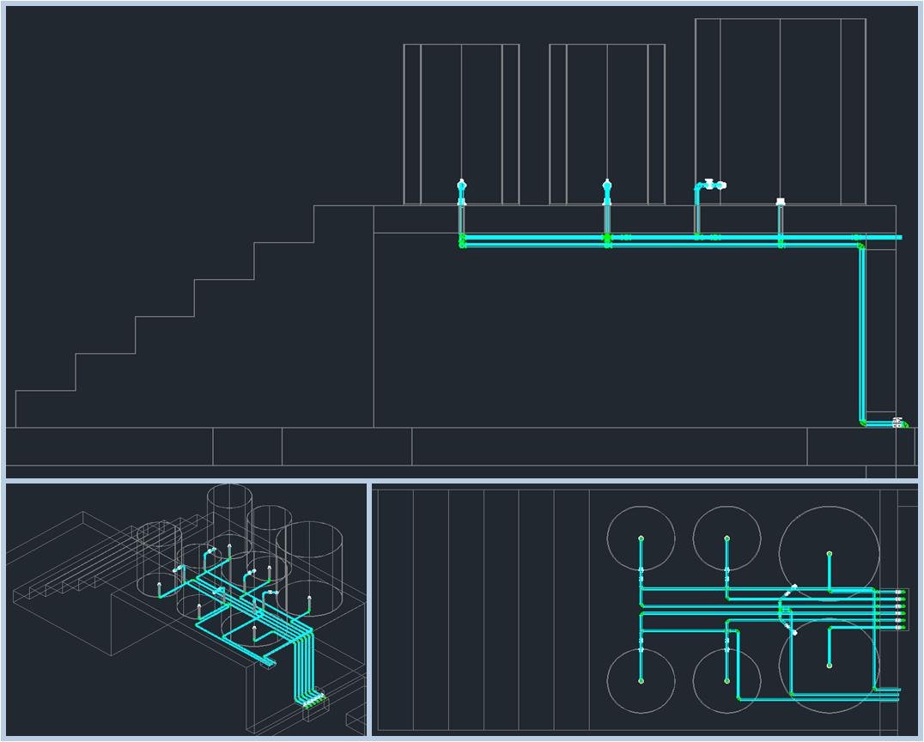
For plants that require volumes slightly larger than the nearest available tank volume, the ADT automatically rounds down to the nearest desired volume to make the size as small as possible.

Chemical Storage Tank Design
Coagulant Tank | Tank Volume | Vol.CoagTank L
Coagulant Tank | Stock Concentration | C.CoagStock kg/m³
Chlorine Tank | Tank Volume | Vol.ChlorineTank L
Chlorine Tank | Stock Concentration | C.ChlorStock kg/m³

Chemical Dose Controller

Dosificador Linear

Coagulation involves the precise dosing of chemical coagulant to the plant influent to neutralize the forces that keep colloids in suspension, thus permitting flocculation. To administer the dose without pumps, AguaClara plants utilize a dosing system that consists of tanks to store the coagulant solution, a platform to maintain the needed elevation, a constant head tank with a float valve, a scale, and a dosing tube.

The coagulant solution must be stored in stank tanks on an elevated platform. The chemical solution must flow from the stock tanks to a bottle equipped with a float valve. The float valve is used to maintain a constant head in the bottle, ensure the chemical flows based on a constant hydraulic potential. The solution flows from the contant head tank through a flexible tube mounted on a scale. The inclination of the scale is based on the elevation of a float attachment that sits in the entrance tank, which is related to the plant flow rate. A slider is used to adjust the position of the flexible tube alone the scale, thus determining the dose of coagulant. The doser is calibrated such that when there is no flow in the plant, the scale sits horizontally, preventing coagulant flow. When the plant is operating, the float rises in proportion to the plant flow, tilting the scale and providing the necessary head to deliver the specified dose. The further away from the float the slider is set, the higher the dose administered.

The coagulant will automatically stop flowing when there is no flow through the plant, and it will automatically administer the specified dose based on the water level in the entrance tank, which is proportional to the plant flow rate as a result of the LFOM.
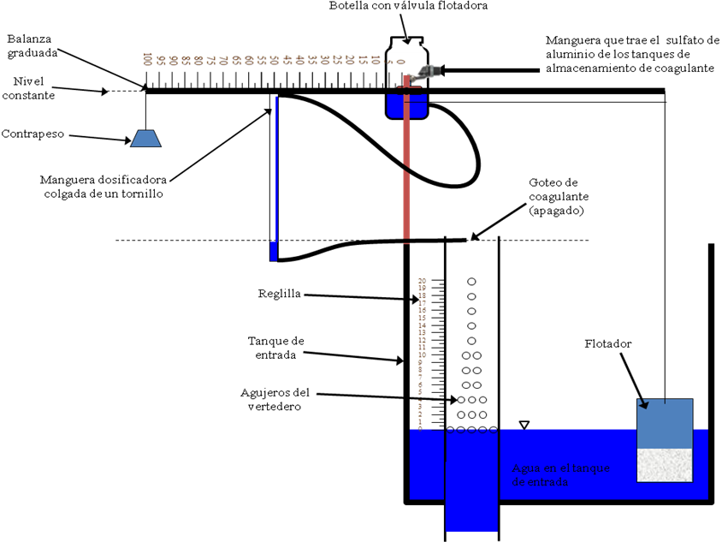
Figure 2 Front view of the chemical dose controller with the scale in the “off” position (with no-flow in the plant).
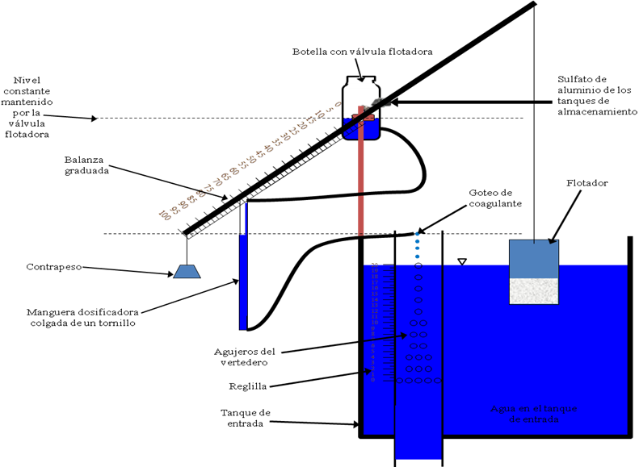
Figure 3. Front view of the chemical dose controller with the scale in operating position. The figure illustrates that the scale must be inclined to provide the hydraulic head required to deliver the corresponding coagulant dose.

The chemical dose controller is mounted on the outside of the entrance tank, and is fed from a valve in the stock tank at Z.CoagTankOutlet from the plant floor. The chemical tank platform must be Z.CoagTank above the plant floor to provide enough hydraulic head (H.CdcMax) between the coagulant tank exit and the constant head tank to make up for losses through the float valve. From the float valve, the solution flows through N.CdcTubes tubes having an inner diameter of D.CdcTube and a length of L.CoagCdcTube to the dosing device, the fulcrum of which is mounted at the top edge of the entrance tank. The length and diameter of the tubes are designed to relate the needed range of coagulant flow rate, 0 to C.CoagDoseMax, to to the maximum flow rate of the plant, while always maintaining laminar flow. The length of the scale from the fulcrum to the float is L.CdcFloatArm in length, and the length of the scale from the fulcrum to the opposite side is L.CdcScaleArm. After passing through the tube, the solution falls freely through a PVC pipe into the tee outside of the entrance tank. There will be sufficient venting to allow air to mix with the water, reducing chances of foam forming in the first channel of the flocculator.

Calibrating the doser

For the doser to function optimally, it is crucial for each component to be installed correctly, and the initial calibration of the doser must be carried out according to the following steps.

Once the doser is installed, the scale needs to be set at the zero level. To do this, empty the entrance tank until there is no flow through the plant. At this point, the water level is just below the bottom orifices of the simulated sutro weir. Then, with the scale perfectly horizontal, adjust the length of the rope attached to the float.

With the scale in the horizontal position, mount the constant head tank such that its water level is at the same elevation as the dosing tube.

Then, fill the entrance tank until the water height corresponds to the maximum flow rate (where the topmost orifices of the LFOM are just submerged). The scale should be set nearly to the maximum height (approximately HL.Lfom)

Position the slider to an intermediate dose. It is important to calibrate the doser at an intermediate dose because this method leaves extreme flow rates less susceptible to calibration errors.

At the intermédiate dosing position, measure the flow of coagulant and compare it to the desired (theoretical) flow rate. If the flow rate is greater than the theoretical, cut the tube and repeat the test until the theoretical value matches the measured value. If the flow rate is less than the theoretical, you need to obtain a larger tube and start the process over. Once the theoretical and measured values match, the doser is ready for use.

It is important to periodically clean each part of the doser. Also, air bubbles, which cause dosing errors, must not be present in the tubes. If bubbles are present, remove the tube from the dosing system and force the bubbles out.

Rapid Mix
Once it has been dosed with coagulant, the water passes through the rapid mix system. Rapid mix serves to uniformly distribute the coagulant through the raw water. In this plant, the rapid mix occurs as turbulent flow through a L.RMPipe long pipe, with an inner diameter of ND.RMPipe. This pipe brings water from the point at which coagulant is dosed to the entrance of the flocculator.

Flocculation
The purpose of flocculation is to agitate the coagulated water, so that the newly-neutralized suspended particles collide together to form larger particulates, or flocs. Collisions are encouraged by forcing the water to make several 180 degree turns around The flocculator is designed for a collision potential of CP.Floc, and a maximum energy dissipation rate of ED.Floc. The collision potential characterizes the probability of flocs colliding and sticking together, which the energy dissipation rate characterizes the likelihood of flocs breaking up. The flocculator encourages the particulates in the water, now neutralized with coagulant, to collide and stick together. As these particulates, or flocs, collide and stick together, they grow heavy enough to settle out by the time they reach the sedimentation tank. Since the particles collide more easily in turbulent flow, turbulence is created by a series of staggered baffles that force the water to make 180 degree turns. The baffles are spread throughout several consecutive channels to maintain a compact design and minimize cost of construction by sharing channel walls. To allow the two tanks to share a wall, the flocculator length is set to that of the sedimentation tank, L.Sed. There are a total of N.FlocChannels channels in the flocculator, each channel having an inner width (excluding wall thickness) of W.FlocChannel.
The flocs need to collide enough times that they grow large enough to settle out in the sedimentation tank, but not so large that they settle out in the flocculator. The required collision potential (the possibility of colliding in the flocculator) is CP.Floc, while the actual collision potential is CP.FlocTotal. Note that the value of the actual collision potential may be significantly higher than the required since the number of floc channels must be an integer.

The height of the flocculator was calculated by summing the head losses within the flocculator, the water height in the sedimentation tank, and a freeboard height of H.PlantFreeboard, giving a total height of H.Floc (excluding floor thickness). The total width (perpendicular to the channels) of the flocculator, including all walls except for the one shared with the sedimentation tank, is W.FlocWithWalls. The total length of the floc tank, including wall thickness, is L.FlocWithWalls. The floor of the flocculator, above the floor thickness, is elevated Z.FlocTank from the sedimentation tank floor, also above the floor thickness. These dimensions together give a residence time in the flocculator of Ti.Floc. The average velocity in the flocculator is V.Floc.

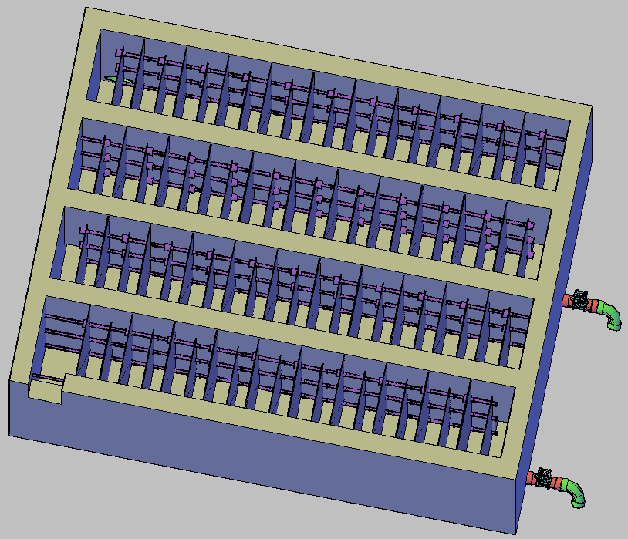
Figure 4: Top view of a vertical flocculator

General Flocculator Design
Gate valves at the bottom of alternate channels in the flocculator allow for draining. The nominal diameter of the flocculator drain pipes is ND.FlocValve, calculated to ensure the tank can drain in less than Ti.FlocDrain. Since each valve is draining the water from at least two channels, this design requires N.FlocValves valves. Elbows connected at the end of the drain piping redirect the flow of water into the drain channel, minimizing splashing.
Since the center of the valve is aligned with the floor (above the floor thickness), slopes need to be built in to allow efficient draining. The width of the slope is the inner diameter of the drain piping, while the depth of it is the inner radius. The length is given to make the slope 30 degrees. In the even that a 30 degree slope causes a slope longer than the space between baffles, the end of the slope is simply set to 5 cm away from the nearest baffle.

Inlet Channel
The influent to the sedimentation tank passes through a channel that distributes the water to the individual bays within each tank. This channel is designed to ensure that the flocs can be transferred to the bottom of the sedimentation tanks without being broken. Other restrictions on the dimensions include: sufficient width to accommodate the inlet manifolds that deliver water to the bottom of tank, tiene que tener suficiente profundidad para apoyar los tubos recolectores de salida de los tanques de sedimentación, tiene que ser poco profundo para permitir fácil acceso al fondo, y tiene W.SedInletchannelPreweir de espacio libre.

Length | L.Channel
Width | W.InletChannel
Height | H.InletChannel
Water height | HW.InletChannel

Table 6. Dimensions of the inlet channel

El canal distribuidor también tiene un vertedero de H.SedWeirInlet de altura sobre el nivel del fondo y un tubo de 4 pulgadas de diámetro fundido en el final del canal. Este tubo se mantiene tapado excepto cuando se quiere botar agua floculada al canal de limpieza para que no ingrese a los tanques de sedimentación. Cuando se desborda agua del canal, el vertedero mantiene el canal y el tanque de floculación llenos de agua para evitar cambios abruptos en el nivel de agua que pueden perjudicar el tratamiento.

Type of weir | PerpendicularParallel with the channel
Length | W.SedWeirInlet
Height | H.SedWeirInlet
Head loss | HL.SedWeirInlet

Table 7. Dimensions of the inlet channel weir

Sedimentation Tanks
The objective of the sedimentation tanks is to remove, by gravity, the flocs that have been formed in the flocculator. Los tanques de sedimentación de flujo ascendente tienen cinco partes: los tubos distribuidores, los canales de drenaje, las tolvas, las placas sedimentadoras, y los tubos recolectores del agua decantada.
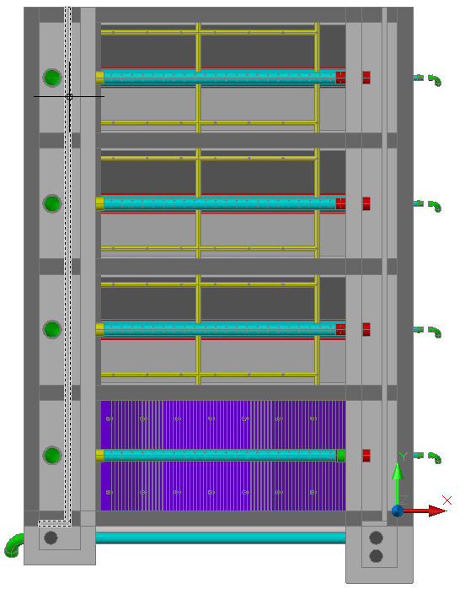
Figure 5:Top view of the sedimentation tank

Assigning dimensions to the sedimentation tank
Se dimensionan los tanques de sedimentación en base a los criterios de diseño de las varias partes descritas anteriormente así como las dimensiones estándares del material de las láminas usadas para las placas sedimentadoras. Láminas de policarbonato, un buen material para placas sedimentadoras por su resistencia y lisura, son comerciales en dimensiones de 3.66 de largo por 1.08 m de ancho por 0.02 m de espesor. Para hacer el uso más eficiente de este material, el algoritmo de dimensionamiento de los tanques de sedimentación de la herramienta de diseño de AguaClara fija el ancho de cada tanque al ancho de la lámina, en 1.08 m, y usa un algoritmo de optimización para escoger un solo largo de todas las placas de tal manera que el diseño requiere la compra de un mínimo número de láminas. Utilizando este constante además de los constantes V_{ascendente}, V_{c}, α, el ángulo de inclinación de las tolvas, el número de tanques de sedimentación deseados, y el caudal máximo de la planta, se calculan las dimensiones de los tanques de sedimentación.

Number of sedimentation tanks | N.SedTanks
Number of sedimentation bays per sedimentation tank | N.SedBays
Width of each bay | W.SedBay
Length of each bay and tank | L.Sed
Altura de las paredes inclinadas | H.SedBayDivider
Ancho de las paredes inclinadas | W.SedSlope
Angulo de inclinación de las paredes | AN.SedSlope

Table 8. Dimensions of the sedimentation tank
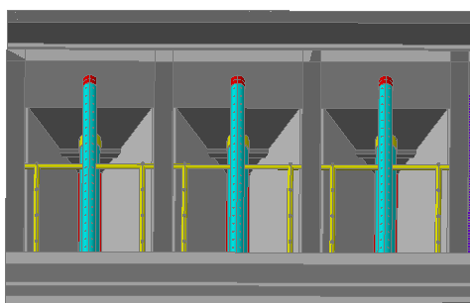
Figure 6: Cámaras sedimentadoras y tolvas del tanque de sedimentación

Inlet Manifolds
The objective of the inlet manifolds is to transport the flocs into the bottom of the sedimentation tank without breaking them. El diseño de los tubos distribuidores también depende del factor de la tasa de disipación de energía máxima, ε_{max}, la idea siempre siendo pasar los flóculos formados a los tanques de sedimentación sin romperlos por demasiada turbulencia. Se determina el diámetro de los tubos de entrada fijando ε_{max} = 6 mW/kg en el lugar donde hay el mayor potencial de romper flóculos: la entrada a los tubos en el fondo del canal distribuidor.
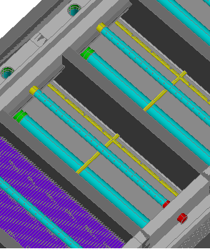
Figure 7: Tuberías del tanque de sedimentación
Each one of the N.SedBays bays in each sedimentation tank has a maximum flow rate of Q.SedBay, which, according to this equation, requires a ND.SedManifold inlet manifold pipe to prevent floc breakup. The length of each inlet manifold pipe is L.SedManifoldPipe, and the pipes have an elevation of Z.SedManifoldLift from the sedimentation tank floor.
The inlet manifolds distribute water along the length of the sedimentation tank through orifices along the bottom of the pipe. The total cross-sectional area of the jets coming out of the manifold must equal the approximate inner diameter of the pipe itself, given by the maximum energy dissipation constraint. La suma de las áreas de los chorros de estos agujeros tiene que ser aproximadamente igual al diámetro del tubo para preservar la tasa de disipación de energía máxima que se toma como criterio para dimensionar el tubo, tomando en cuenta las restricciones de tamaños estándares de brocas para perforar los agujeros. Cada tubo distribuidor tiene N.SedManifolPorts de D.SedManifoldPort de diámetro espaciados a S.SedManifoldBetween centro a centro a lo largo del tubo.
Adjuntos a los agujeros, y en posición perpendicular al tubo de distribución, se encuentran tubitos de longitud L.Diffuser y diámetro D.Diffuser. El propósito de estos tubos verticales es evitar la creación de corrientes circulares en el fondo del tanque de sedimentación y la creación de zonas muertas, donde los sedimentos pueden ser acumulados.

Nominal diameter | ND.SedManifold
Diameter of the orifices | D.SedManifoldPort
Number of orifices | N.SedManifoldPorts
Center-to-center distance between orifices | B.SedManifoldPort
Length | L.SedManifoldPipe
Elevation from the sed tank floor | Z.SedManifold
Espacio entre el centro de la tubería y la cubierta | S.SedManifoldBetween

Table 9. Dimensions of the inlet manifold

Sludge drain
El en fondo de cada tanque de sedimentación hay un canal de drenaje para purgar los lodos acumulados en el proceso de sedimentación. El canal es un hueco de W.SedSludge ancho por H.SedSludge de alto que recorre todo el largo del fondo del tanque. En un lado del tanque, el canal da a una válvula de bronce de D.SedSludgeValve de diámetro que controla el nivel de lodo en el tanque. Encima del canal de cada tanque se colocan placas de ferrocemento perforados con N.SedsludgeOrifices de D.SedsludgeOrifice espaciados a B.SedSludgeOrifices de centro a centro. Estos agujeros están distribuidos uniformemente a lo largo del canal para lograr purgar los lodos de todas las partes del tanque uniformemente. Los diámetros de los agujeros en el canal y el diámetro de la válvula están diseñados para vaciar un tanque en Ti.SedDrain .

Width | W.SedSludge
Height | H.SedSludge
Ancho de la tapadera | W.SedDrainCover
Grosor de la tapadera | T.SedSludge
Diameter of the sludge orifices | D.SedSludgeOrifice
Center-to-center distance between the sludge orifices | B.SedSludgeOrifices
Número de orificios | N.SedSludgeOrifices

Table 10. Dimensions of the sludge drain

Tolvas
Cada tanque tiene una tolva de AN.SedSlope de inclinación y una elevación de Z.SedSlopes. Esta geometría crea mayores velocidades en el fondo del tanque que en la parte superior de la tolva, lo cual sirve para mantener los flóculos sedimentados en suspensión, maximizando el potencial de floculación y retención de partículas en un manto de lodo. La velocidad ascendente del agua en la parte superior de la tolva se fija en V_{ascendente} = 69 m/día (8 mm/s) en la herramienta de diseño de AguaClara.

Plate settlers
Plate settlers, used to remove small particulates that cannot settle in the bottom of the tank, sit above the slopes in the sedimentation tank. The plate settlers are set an an angle of AN.SedPlate to ensure efficient sedimentation. Los algoritmos de diseño de la AguaClara Design Tool utilizan el constante de la velocidad de captura V_{c} = 9.0 m/día (0.104 mm/s) que garantiza una velocidad conservadora para un alta remoción de sólidos.
Cada canal del tanque de sedimentación de la planta tiene un total de N.SedPlates placas sedimentadoras organizadas en N.SedModules módulos de N.SedModulePlates placas. Los módulos descansan en un marco de tubería de PVC colocado en la parte superior de las tolvas.

Width of the plate settlers | W.SedPlate
Length of the plate settlers | L.SedPlate
Center-to-center spacing of the plate settlers | B.SedPlate
Number of plate settlers | N.SedPlates
Number of plate settler modules | N.SedModules
Number of plate settlers in each module | N.SedModulePlates

Table 11. Dimensions of the plate settlers

Launders
En el tanque de sedimentación el agua pasa por el tubo distribuidor en el fondo, la tolva, y las placas sedimentadoras. Al salir de las placas el agua ya está decantada o aclarada. Sale del tanque por un tubo recolector perforado ubicado inmediatamente sobre la parte superior de las placas. El tubo recolector está diseñado para proporcionar significativamente más pérdida de carga hidráulica en las pérdidas menores de los orificios perforados que en las pérdidas mayores ocasionadas por el flujo turbulento dentro del tubo, de tal manera que el flujo que entra el tubo recolector por los orificios es uniforme a lo largo del tanque. Por esta razón cada tubo recolector de ND.SedLaunder de diámetro lleva N.SedLaunderOrifices agujeros de D.SedLaunderOrifice de diámetro espaciados a B.sedLaunderOrifices de centro a centro en N.SedLaunderOrificesRow filas en la parte superior del tubo. Este diseño tiene el beneficio de crear un sobrenadante sobre el tubo recolector que evita que material flotante en la superficie del agua salga del tanque de sedimentación.
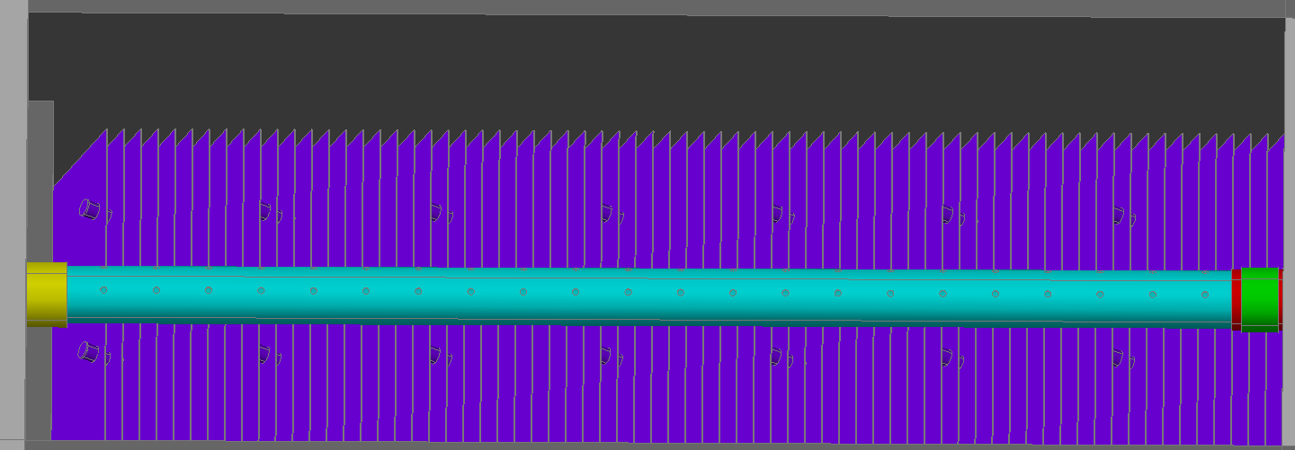

Figure 8: The launder in a sedimentation bay

Number of orifices in the launder | N.SedLaunderOrifices.
Nominal diameter of the launder | ND.SedLaunder.
Elevation of the launder | Z.SedLaunder.
Total number of launders in the plant | N.Launders.
Length of each launder | L.SedLaunder.

Table 12. Launder dimensions

Canal de salida
El agua decantada sale de los tubos recolectores a un canal recolector de salida que lleva el agua al proceso de desinfección. Este canal tiene dimensiones de H.ExitChannel de profundidad, W.ExitChannel de ancho, y L.ExitChannel de largo. Un vertedero longitudinal de cresta aguda de H.SedExitChannelWeir de elevación en medio del canal garantiza que los tanques de sedimentación se mantienen llenos de agua con un mínimo de pérdida ocasionada por el vertedero.

Chlorine Disinfection
Se dosifica una solución de hipoclorito de calcio al agua decantada en la caja distribuidora al final del canal de salida. El sistema de dosificación de cloro es parecido al del coagulante y consiste en: tambos para almacenar la solución de cloro, una mesa para elevar los tambos, y un dosificador sencillo gravitacional.
Se monta el dosificador sencillo en el borde de la caja distribuidora de tal manera que las gotas de cloro caen al efluente de la planta, donde se mezclan con el agua. El operador de la planta maneja la manguera dosificadora de este dispositivo para escoger la dosis apropiada de cloro para el caudal que se trata. Hay suficiente tiempo de contacto en las líneas de conducción y los tanques de abastecimiento para lograr la desinfección. La válvula flotadora del dosificador sencilla se posiciona sobre el borde de la solera superior del canal de salida. La mesa para los tambos de cloro debe ser diseñada con una elevación suficiente para proporcionar la carga hidráulica necesaria para que la solución de cloro pueda llegar a la botella con flotador, superando las pérdidas ocasionadas por la válvula flotadora y la manguera de suministro. Se almacenan las soluciones de cloro en dos tambos colocados encima de la mesa.
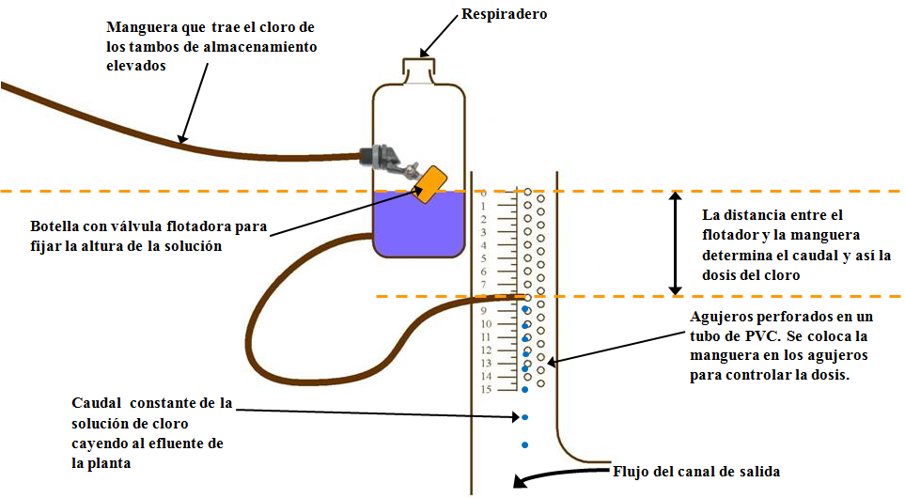
Figure 9: Diagrama de un dosificador de cloro

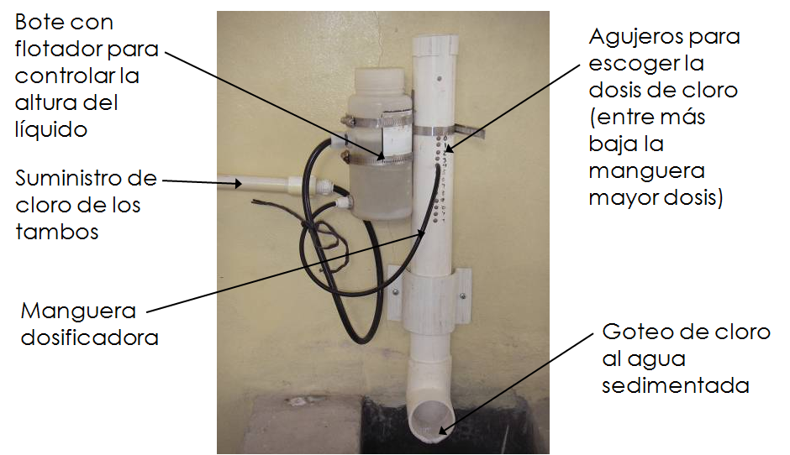

Figure 10: Fotografía de un dosificador de cloro en una de las plantas existentes de AguaClara

Manejo de lodos
Cada proceso de la planta produce residuos. El tanque de entrada produce sólidos sedimentables, los tambos de coagulante residuos de impurezas de la solución química, los tanques de floculación y sedimentación lodos de flóculos, y los tambos de cloro residuos químicos. Hay dos salidas de lodos principales. La primera salida es el canal de lodos del tanque de entrada, que tiene un ancho de W.EtDC, un largo de L.EtDC, y una altura de H.EtDC. La segunda salida recoge los residuos de los procesos de floculación y sedimentación y conduce los residuos a un canal de limpieza ubicado a lo largo de la pared posterior de la planta. El acceso a las válvulas manuales de floculación y sedimentación es a través de tapaderas en el pasillo que cubre el canal de limpieza. Este pasillo queda debajo del piso del resto de la planta para permitir acceso manual a las válvulas. Esta salida tiene una altura de H.DC, una longitud de L.DC, y un ancho de W.DC.

Stacked Rapid Sand Filtration: SRSF

Las plantas de AguaClara cuentan con un sistema de filtración no convencional. Comúnmente, solamente plantas de grandes caudales pueden permitirse la incorporación de un filtro de arena. Los filtros de arena convencionales usan grandes cantidades de agua limpia para el retrolavado, electricidad, y son de construcción y mantenimiento complejo, incluyendo varias válvulas y piezas que se rompen con facilidad y son difíciles de reponer.
Por estas razones, el equipo de AguaClara ha diseñado un filtro con unas restricciones de diseño que no use electricidad, evite el uso de válvulas y piezas caras y de difícil obtención, que use poca agua, que cada parte del filtro sea visible y accesible para el operador, y que sea de fácil manejo.

Usando los principios de perdida de cabeza y aprovechando las diferencias de altura del agua, el equipo de AguaClara creo un diseño de tres filtros de arena en uno (FRAMCa). Este diseño reduce la cantidad de agua que se necesita, y gracias a su tamaño compacto y sencillo, una planta de relativamente poco flujo puede contar con tres filtros de arena.

Filtration begins once the settled water leaves the sedimentation tank. To ensure the filter functions optimally, the water must be sufficiently treated at the start of the process to a low turbidity. The filter must be washed regularly to liberate particulates trapped in the void space of the filter media. Once the water leaves the filter, it is sent to a distribution tank where chlorine is applied to destroy the last of the particulates.

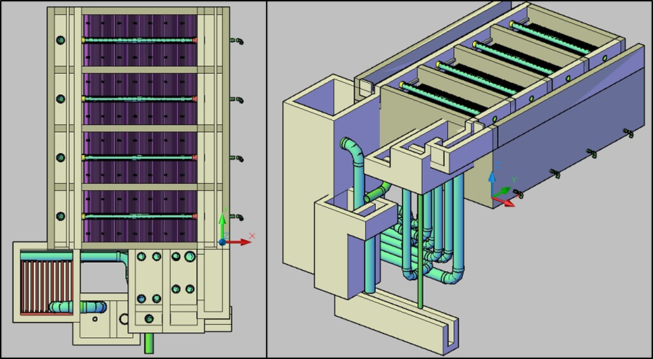
Figure 11. ( Left) Top view of the sedimentation tank and a single filter below it. (Right) Isometric view of the filtration unit and sedimentation tank.
The SRSF has eight components:an entrance channel, an entrance box, a filter box, a distribution tank, caja de salida, caja de rebose, a backwash channel, a backwash box, and a siphon.

Figure 12 and Error: Reference source not found show the layout of the filter. Water from the sedimentation tank enters the entrance channel then into the entrance box over a weir, flowing into the inlet manifold pipes. During filtration, all four pipes are utilized to distribute flow evenly to each of the six sand layers in the filter box and flow exits through the exit manifold into the exit box. Once in the exit box, the filtered water flows over a weir and is then piped to a distribution tank.
Figure 11Error: Reference source not found more clearly shows the parts of the filter associated with backwash. For backwash operation, all water in the entrance channel will only flow through the bottom inlet manifold pipe. The dirty backwash water will then flow through the siphon into the backwash box. The backwash weir makes up one wall of the backwash box and controls the height of water throughout the filtration system. The dirty water flows over the weir from the backwash box into the backwash overflow box, then down a pipe to the drain channel.

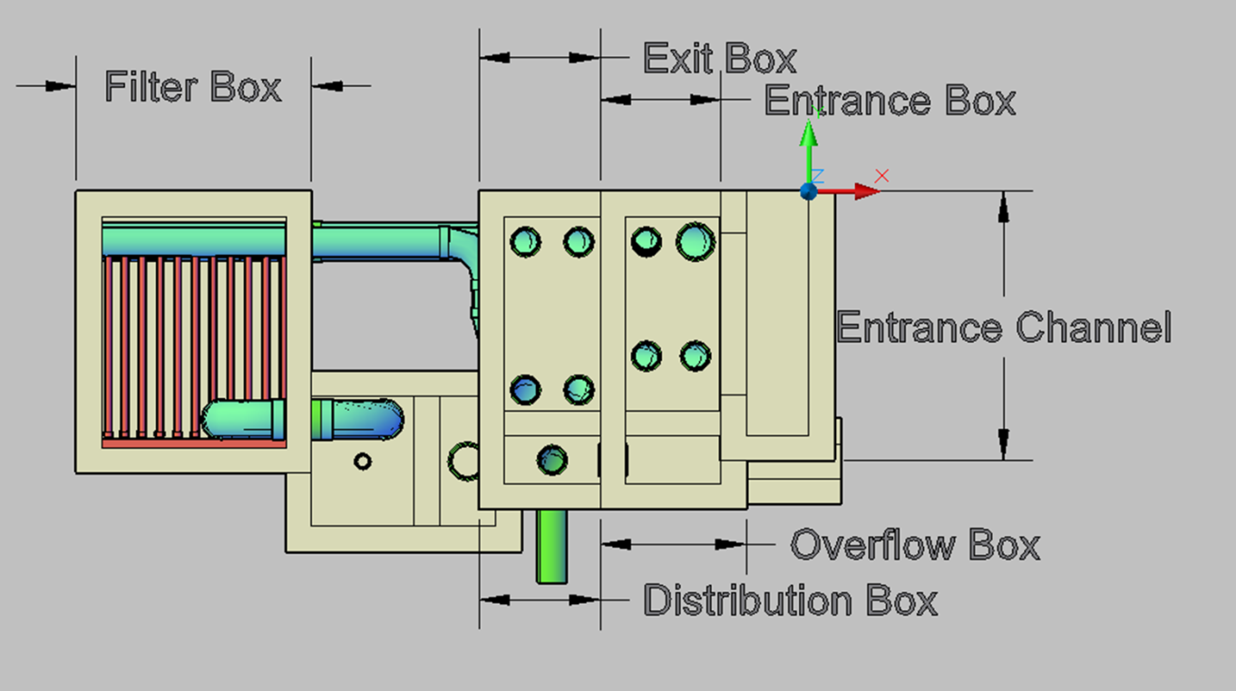
Figure 12. Top view of the filter labeled for filtration flow.

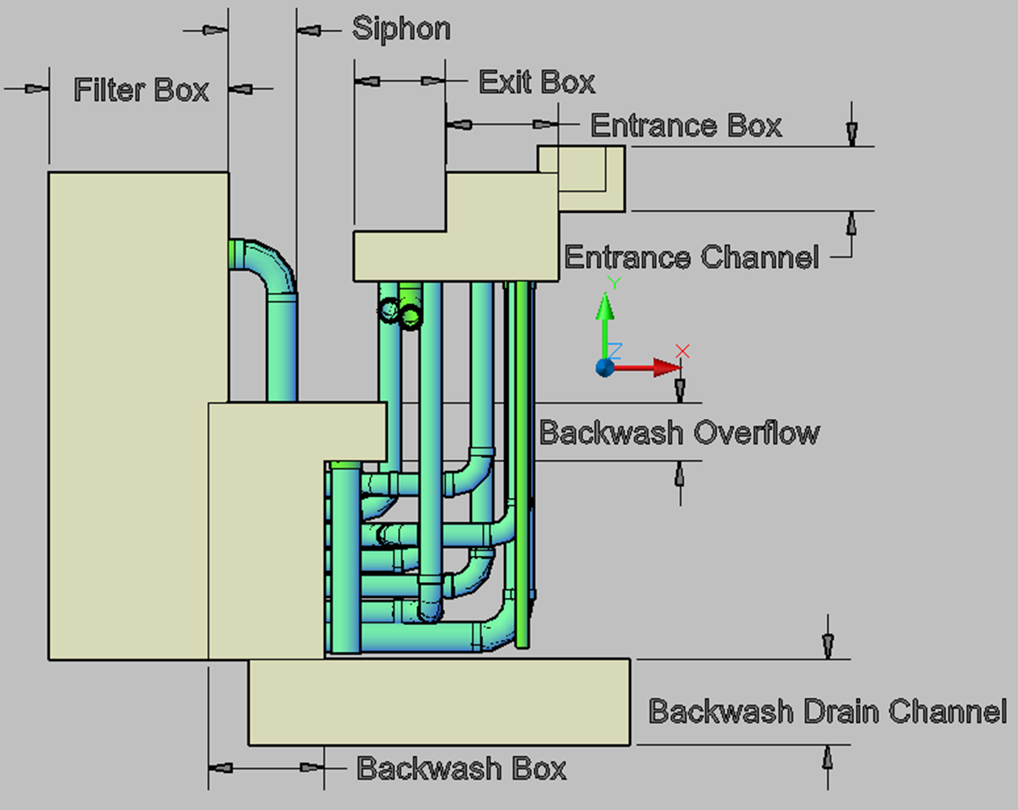

The siphon must be large enough to allow for draining all the water in the filter in a reasonable amount of time, set to be 3 minutes as well as have less than 10 cm of head loss at steady state.

Materials List

Esta seccion describe parametros utiles y estimaciones de los materials necesarios para la construccion de esta planta. Las dimensiones y materials descritas aqui estan divididas acorde a la unidad operacional de la planta a la que pertenecen.

Entrance Tank
- El volumen de concreto necesario para construir el tanque de entrada es Vol.EntranceTank.
- El suelo del tanque de entrada tiene un area de A.EtFloor.

Flocculation Tank
- El volume de concreto necesario para construir los suelos del tanque de floculacion es Vol.FlocFloor y Vol.FlocWallsn par alas paredes del tanque.
- Este suelo tiene un area de A.FlocFloor.
- Hay N.FlocValves valvulas en el tanque de floculacion , cada una con un día metro nominal de ND.FlocValve.
- Esta planta no tiene laminas de plastico.\*

Sedimentation Tank
- Los volumenes de concreto necesario para construir el tanque de sedimentación son:
Vol.SedSlopes | Para las tolvas del tanque
Vol.SedWalls | Para las paredes del tanque
Vol.SedFloor | Para el suelo del tanque
- El area de la superficie del tanque de sedimentación es A.SedFloor.
- Hay N.Launders tuberias de salida de agua limpia, cada una de longitude L.SedLaunder length y ND.SedLaunder de día metro. Cada tuberia de salida tiene dos filas de orificios con un total de N.SedLaunderOrifices orificios, cada uno de día metro D.SedLaunderOrifice.
- Cada una de las tuberias distribuidoras tiene longitud de L.SedManifoldPipe, con un día metro nominal de ND.SedManifold. Hay N.SedBays tuberias distribuidoras.
- Hay un total de N.SedPlatesTotal placas sedimentadoras, cada una de longitud L.SedPlate y W.SedPlate de ancho.
- Hay N.Valves valvulas, cada una de ND.SedSludgeValve día metro nominal.

SRSF

